[](http://www.ds-sol.ru/tinybrowser/fulls/images/skan/40/4/1.jpg)

[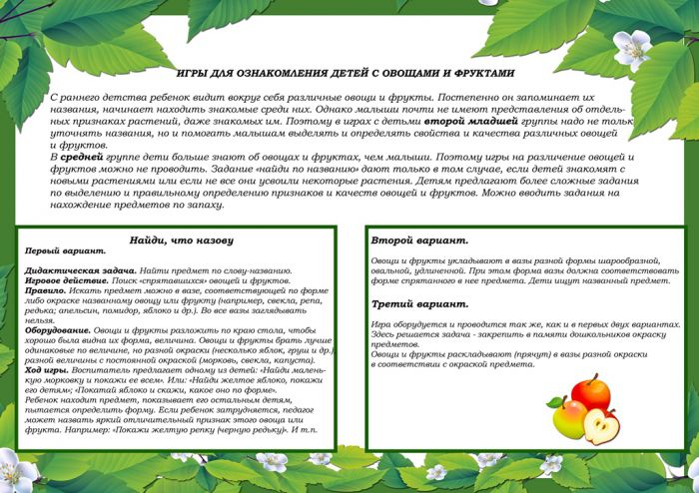](http://www.ds-sol.ru/tinybrowser/fulls/images/skan/40/4/5.jpg)

[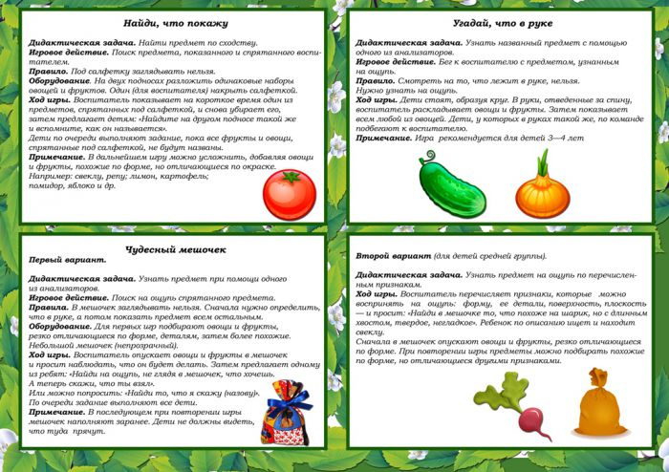](http://www.ds-sol.ru/tinybrowser/fulls/images/skan/40/4/6.jpg)

[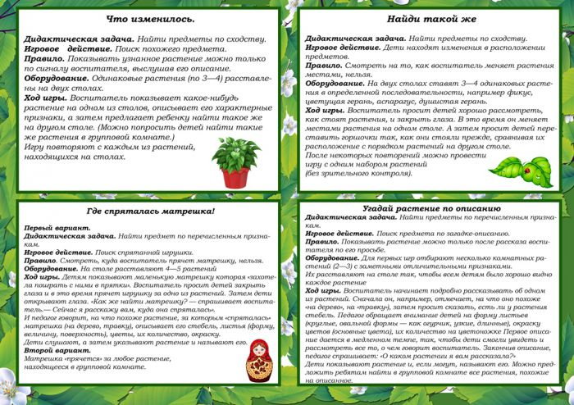](http://www.ds-sol.ru/tinybrowser/fulls/images/skan/40/4/9.jpg)

[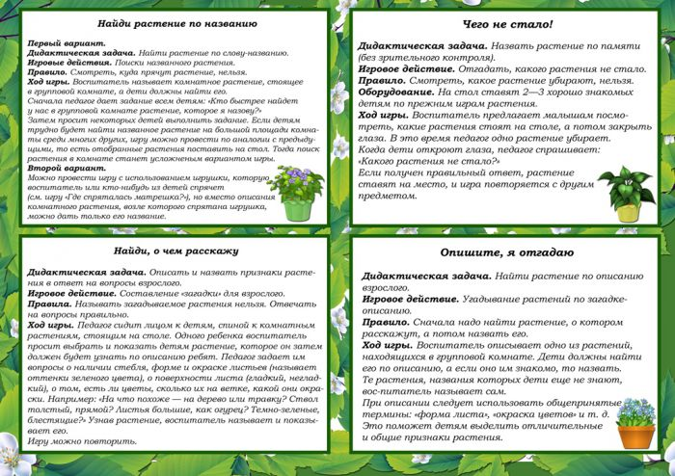](http://www.ds-sol.ru/tinybrowser/fulls/images/skan/40/4/10.jpg)

[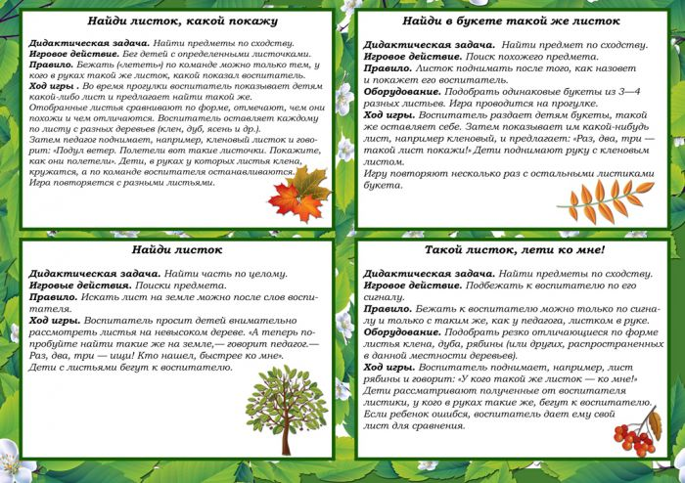](http://www.ds-sol.ru/tinybrowser/fulls/images/skan/40/4/12.jpg)

**[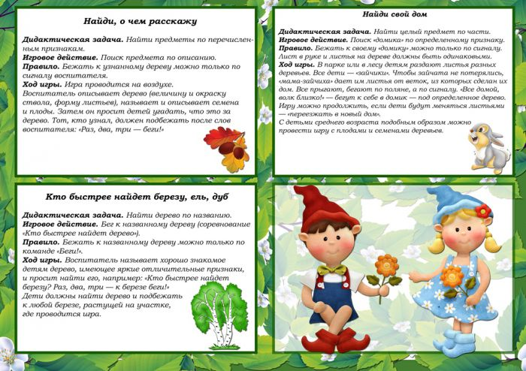](http://www.ds-sol.ru/tinybrowser/fulls/images/skan/40/4/13.jpg)**

