[](https://ok.ru/dk?cmd=PopLayerPhoto&st.layer.cmd=PopLayerPhotoOuter&st.layer.type=GROUP&st.layer.revNav=off&st.layer.limitedUi=false&st.layer.closeLayers=off&st.layer.sphotoIds=893027834299;893027834555;893027834811;893027835067;893027835323;893027835579&st.layer.showNav=on&st.layer.photoAlbumId=54810570129595&st.layer.epm=off&st.layer.plc=mediaTopic&st.layer.photoId=893027834299&st.layer.wasRedirect,=off&st.layer.opl=off&st.layer.navStartPhotoId=893027834299&st.layer.navStartAlbumId,=54810570129595&st.layer.sbd=off&st.cmd=altGroupMain&st.groupId=54398474911931&st.referenceName=site212d&st._aid=GroupTopicLayer_openPhotoLayer)

[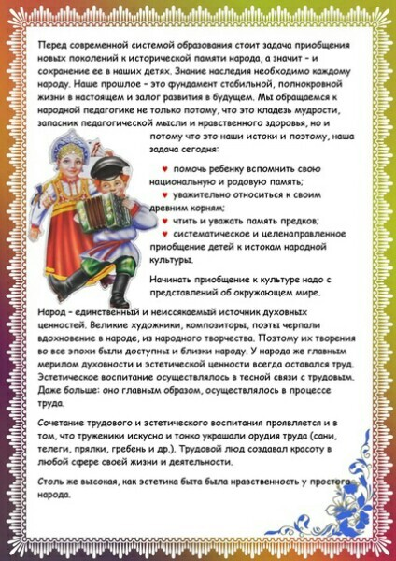](https://ok.ru/dk?cmd=PopLayerPhoto&st.layer.cmd=PopLayerPhotoOuter&st.layer.type=GROUP&st.layer.revNav=off&st.layer.limitedUi=false&st.layer.closeLayers=off&st.layer.sphotoIds=893027834299;893027834555;893027834811;893027835067;893027835323;893027835579&st.layer.showNav=on&st.layer.photoAlbumId=54810570129595&st.layer.epm=off&st.layer.plc=mediaTopic&st.layer.photoId=893027834555&st.layer.wasRedirect,=off&st.layer.opl=off&st.layer.navStartPhotoId=893027834555&st.layer.navStartAlbumId,=54810570129595&st.layer.sbd=off&st.cmd=altGroupMain&st.groupId=54398474911931&st.referenceName=site212d&st._aid=GroupTopicLayer_openPhotoLayer)

[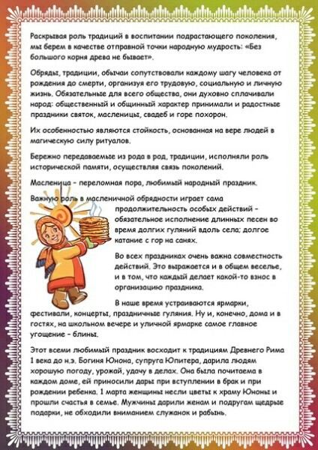](https://ok.ru/dk?cmd=PopLayerPhoto&st.layer.cmd=PopLayerPhotoOuter&st.layer.type=GROUP&st.layer.revNav=off&st.layer.limitedUi=false&st.layer.closeLayers=off&st.layer.sphotoIds=893027834299;893027834555;893027834811;893027835067;893027835323;893027835579&st.layer.showNav=on&st.layer.photoAlbumId=54810570129595&st.layer.epm=off&st.layer.plc=mediaTopic&st.layer.photoId=893027834811&st.layer.wasRedirect,=off&st.layer.opl=off&st.layer.navStartPhotoId=893027834811&st.layer.navStartAlbumId,=54810570129595&st.layer.sbd=off&st.cmd=altGroupMain&st.groupId=54398474911931&st.referenceName=site212d&st._aid=GroupTopicLayer_openPhotoLayer)

[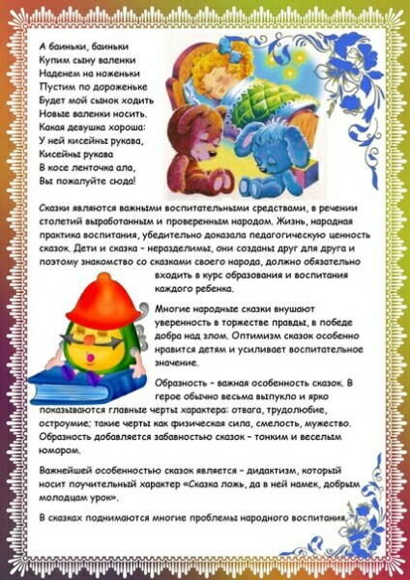](https://ok.ru/dk?cmd=PopLayerPhoto&st.layer.cmd=PopLayerPhotoOuter&st.layer.type=GROUP&st.layer.revNav=off&st.layer.limitedUi=false&st.layer.closeLayers=off&st.layer.sphotoIds=893027834299;893027834555;893027834811;893027835067;893027835323;893027835579&st.layer.showNav=on&st.layer.photoAlbumId=54810570129595&st.layer.epm=off&st.layer.plc=mediaTopic&st.layer.photoId=893027835067&st.layer.wasRedirect,=off&st.layer.opl=off&st.layer.navStartPhotoId=893027835067&st.layer.navStartAlbumId,=54810570129595&st.layer.sbd=off&st.cmd=altGroupMain&st.groupId=54398474911931&st.referenceName=site212d&st._aid=GroupTopicLayer_openPhotoLayer)

[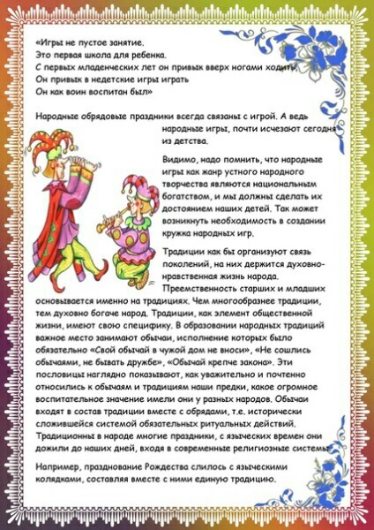](https://ok.ru/dk?cmd=PopLayerPhoto&st.layer.cmd=PopLayerPhotoOuter&st.layer.type=GROUP&st.layer.revNav=off&st.layer.limitedUi=false&st.layer.closeLayers=off&st.layer.sphotoIds=893027834299;893027834555;893027834811;893027835067;893027835323;893027835579&st.layer.showNav=on&st.layer.photoAlbumId=54810570129595&st.layer.epm=off&st.layer.plc=mediaTopic&st.layer.photoId=893027835323&st.layer.wasRedirect,=off&st.layer.opl=off&st.layer.navStartPhotoId=893027835323&st.layer.navStartAlbumId,=54810570129595&st.layer.sbd=off&st.cmd=altGroupMain&st.groupId=54398474911931&st.referenceName=site212d&st._aid=GroupTopicLayer_openPhotoLayer)

[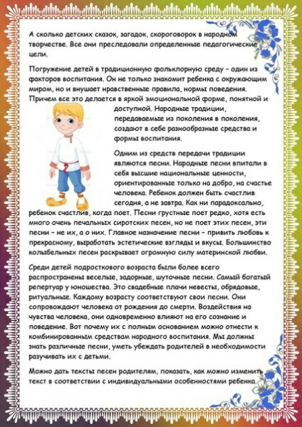](https://ok.ru/dk?cmd=PopLayerPhoto&st.layer.cmd=PopLayerPhotoOuter&st.layer.type=GROUP&st.layer.revNav=off&st.layer.limitedUi=false&st.layer.closeLayers=off&st.layer.sphotoIds=893027834299;893027834555;893027834811;893027835067;893027835323;893027835579&st.layer.showNav=on&st.layer.photoAlbumId=54810570129595&st.layer.epm=off&st.layer.plc=mediaTopic&st.layer.photoId=893027835579&st.layer.wasRedirect,=off&st.layer.opl=off&st.layer.navStartPhotoId=893027835579&st.layer.navStartAlbumId,=54810570129595&st.layer.sbd=off&st.cmd=altGroupMain&st.groupId=54398474911931&st.referenceName=site212d&st._aid=GroupTopicLayer_openPhotoLayer)