**Консультация для родителей**

**Как превратить самые обычные шашки**

**в 5 интересных игр**

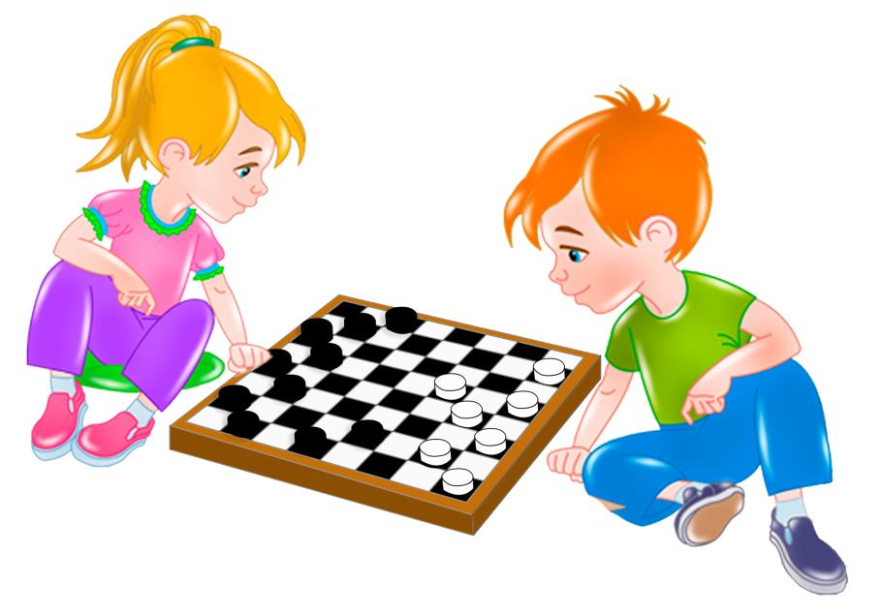

[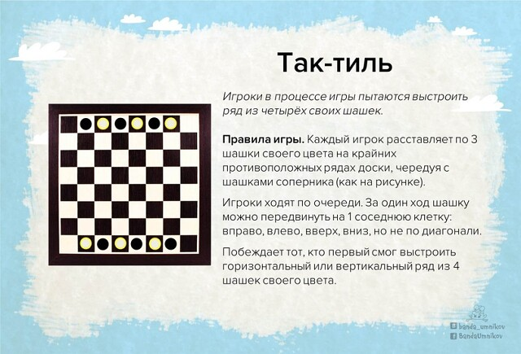](https://ok.ru/dk?cmd=PopLayerPhoto&st.layer.cmd=PopLayerPhotoOuter&st.layer.type=GROUP&st.layer.revNav=off&st.layer.limitedUi=false&st.layer.closeLayers=off&st.layer.sphotoIds=892391941563;892391941819;892391942075;892391942331;892391942587&st.layer.showNav=on&st.layer.photoAlbumId=54810570129595&st.layer.epm=off&st.layer.plc=mediaTopic&st.layer.photoId=892391941563&st.layer.wasRedirect,=off&st.layer.opl=off&st.layer.navStartPhotoId=892391941563&st.layer.navStartAlbumId,=54810570129595&st.layer.sbd=off&st.cmd=altGroupMain&st.groupId=54398474911931&st.referenceName=site212d&st._aid=GroupTopicLayer_openPhotoLayer)

[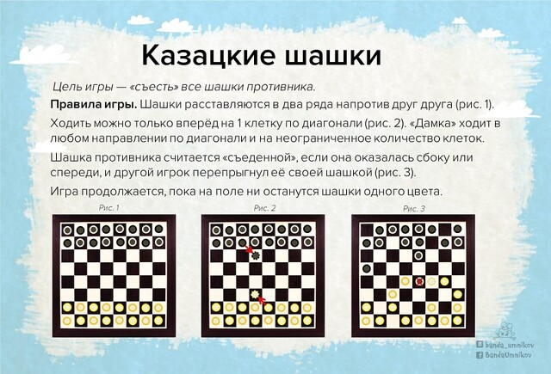](https://ok.ru/dk?cmd=PopLayerPhoto&st.layer.cmd=PopLayerPhotoOuter&st.layer.type=GROUP&st.layer.revNav=off&st.layer.limitedUi=false&st.layer.closeLayers=off&st.layer.sphotoIds=892391941563;892391941819;892391942075;892391942331;892391942587&st.layer.showNav=on&st.layer.photoAlbumId=54810570129595&st.layer.epm=off&st.layer.plc=mediaTopic&st.layer.photoId=892391942075&st.layer.wasRedirect,=off&st.layer.opl=off&st.layer.navStartPhotoId=892391942075&st.layer.navStartAlbumId,=54810570129595&st.layer.sbd=off&st.cmd=altGroupMain&st.groupId=54398474911931&st.referenceName=site212d&st._aid=GroupTopicLayer_openPhotoLayer)

[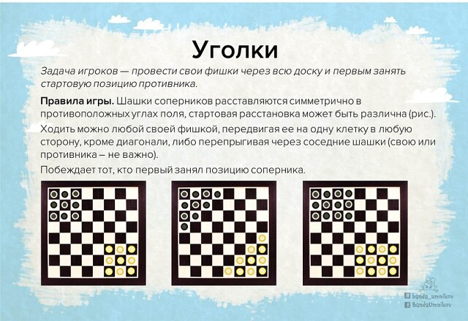](https://ok.ru/dk?cmd=PopLayerPhoto&st.layer.cmd=PopLayerPhotoOuter&st.layer.type=GROUP&st.layer.revNav=off&st.layer.limitedUi=false&st.layer.closeLayers=off&st.layer.sphotoIds=892391941563;892391941819;892391942075;892391942331;892391942587&st.layer.showNav=on&st.layer.photoAlbumId=54810570129595&st.layer.epm=off&st.layer.plc=mediaTopic&st.layer.photoId=892391942331&st.layer.wasRedirect,=off&st.layer.opl=off&st.layer.navStartPhotoId=892391942331&st.layer.navStartAlbumId,=54810570129595&st.layer.sbd=off&st.cmd=altGroupMain&st.groupId=54398474911931&st.referenceName=site212d&st._aid=GroupTopicLayer_openPhotoLayer)

[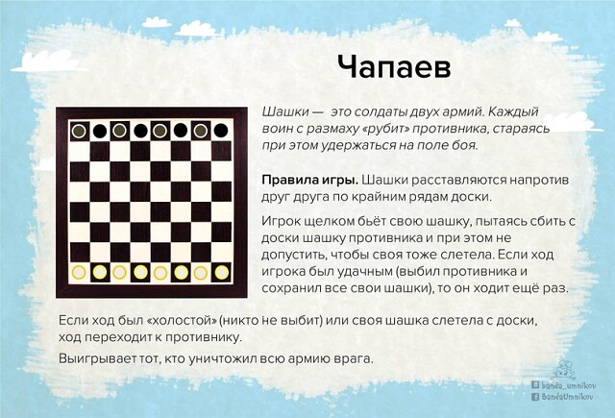](https://ok.ru/dk?cmd=PopLayerPhoto&st.layer.cmd=PopLayerPhotoOuter&st.layer.type=GROUP&st.layer.revNav=off&st.layer.limitedUi=false&st.layer.closeLayers=off&st.layer.sphotoIds=892391941563;892391941819;892391942075;892391942331;892391942587&st.layer.showNav=on&st.layer.photoAlbumId=54810570129595&st.layer.epm=off&st.layer.plc=mediaTopic&st.layer.photoId=892391942587&st.layer.wasRedirect,=off&st.layer.opl=off&st.layer.navStartPhotoId=892391942587&st.layer.navStartAlbumId,=54810570129595&st.layer.sbd=off&st.cmd=altGroupMain&st.groupId=54398474911931&st.referenceName=site212d&st._aid=GroupTopicLayer_openPhotoLayer)

[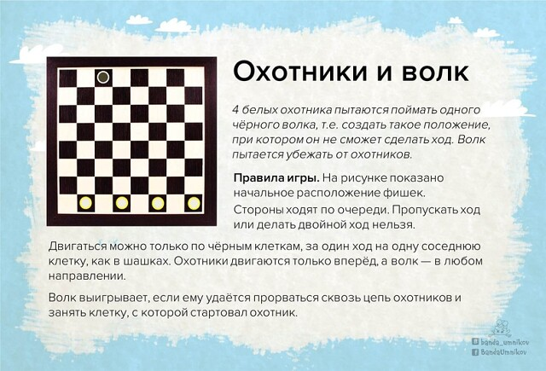](https://ok.ru/dk?cmd=PopLayerPhoto&st.layer.cmd=PopLayerPhotoOuter&st.layer.type=GROUP&st.layer.revNav=off&st.layer.limitedUi=false&st.layer.closeLayers=off&st.layer.sphotoIds=892391941563;892391941819;892391942075;892391942331;892391942587&st.layer.showNav=on&st.layer.photoAlbumId=54810570129595&st.layer.epm=off&st.layer.plc=mediaTopic&st.layer.photoId=892391941819&st.layer.wasRedirect,=off&st.layer.opl=off&st.layer.navStartPhotoId=892391941819&st.layer.navStartAlbumId,=54810570129595&st.layer.sbd=off&st.cmd=altGroupMain&st.groupId=54398474911931&st.referenceName=site212d&st._aid=GroupTopicLayer_openPhotoLayer)

**Желаем успехов и побед в этой увлекательной игре!**

